Jennifer Ann Simpson - CSRA Neuromuscular Massage Clinic
IANMT, CNMT, CMT, CFT, FT, RNRP, AKN, MMP ~ NPI#1104067834 / GA License # MT00675
706-513-8939 / CSRAmassagebyjen@live.com

When filling out this health history you are protected under HIPPA. The Privacy Rule is located at 45 CFR Part 160 and Subparts A and E of Part 164. At HHS.GOV. You do not have to disclose any personal information other than your health to protect both you and the therapist. This disclosed information is not to be transferred from the hands of the therapist or the client without written consent only. Not by email, Internet, going green or verbal. I would need a complete hand written request by you (the client) and your signature as it appears on your driver’s license to prove it is you and only you before I will share anything at all at any time. Your privacy and safety is my upmost concern.

FOR MY MILITARY AND MY FELLOW ARMED SERVICES PLEASE LET ME KNOW OF YOUR STATUS, IF YOU ARE SUFFERING FROM DISABILITIES RELATED TO YOUR SERVICE TO INCLUDE PTSD AND IF YOU NEED ASSISTANCE WITH YOUR VA CLAIM TO INCREASE OR PROTECT YOUR RATING STATUS.

NAME: _________________________________ ADDRESS ______________________________
DOB: _________________________________ ______________________________
PHONE (S) _________________________________ ______________________________

PLEASE INDICATE AREAS OF FOCUS ON THE CHART BELOW:

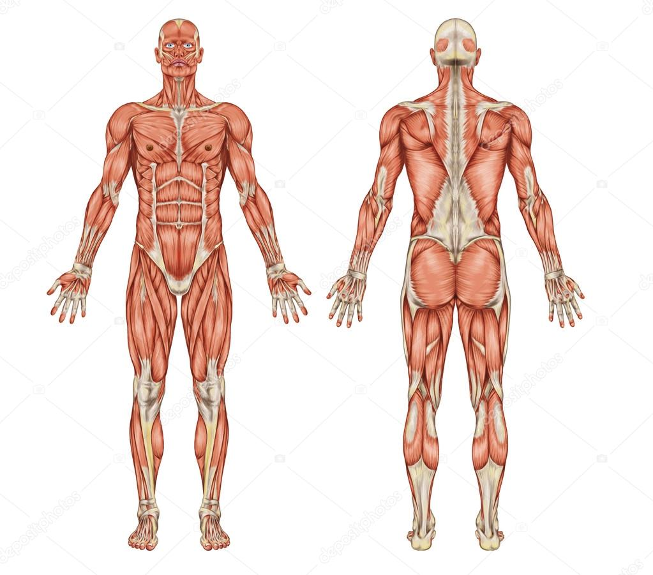
PRESSURE YOU PREFER? LIGHT__________ MEDIUM___________ DEEP_____________
DISCOMFORT LEVEL? Nagging? __ Burning? __ Aching? __ Stabbing? __. Sharp? __ Pins/Needles? __ Numb? __ Itching? __
MEDICATIONS/SUPPLIMENTS: ____________________________________________________________
PHYSICIAN’S CARE? ____________________________________________________________
FOR WHICH CONDITION (S)? ____________________________________________________________
ALLERGIES? ____________________________________________________________

If you are asking for relaxation we do not have to talk. If you are here for therapeutic, I will be asking for biofeedback as we move through the therapy session.

***IMPORTANT***
It is extremely important that you inform me of any contagious pathology that you may have or if you are undergoing Chemotherapy. In addition please inform me of any current open lesions or abrasions to prevent any transfer/infection. This does not necessarily contraindicate you for a massage. It only means that I may have to use gloves during the session, which will not diminish the affect of the treatment. It is my responsibility to keep both of us safe and protected for the best possible therapy.

This is a professional environment and I am a medically based massage therapist. Should there be any inappropriate behavior noted during the treatment session; the therapist has the right to cancel the session and demand full payment.

I certify that the above information is complete and accurate. I will keep the therapist informed of any changes as they occur and complete an amendment to my existing health history.

TO CLIENT: Your personal medical and health information will not be disclosed without written consent given by you after a request has been made. In addition, any authorization may be revoked in writing unless I have taken any action in reliance on the authorization. A second party may be used in Insurance Billing and all personal information will be kept in complete compliancy with protection for your integrity.

I am a Nationally Certified and licensed massage therapist that may suggest types of treatment, exercises and stretches as part of your home care program. I am not physician that can diagnose. I am only authorized within my scope of practice to give you my professional opinion from my extended medical background.

I am prepared to speak with your physician at your request in regard to your treatment plan and in doing so will need your written request.

The therapist is not liable for any injury or loss while on the premises of CSRA Neuromuscular Massage.

Client signature _________________________________________ date _________________________

MEMBER OF THE FOLLOWING ORGANIZATIONS:
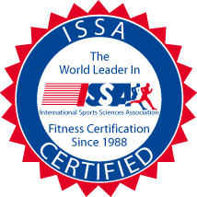

Lastly, if you want silence and no biofeedback during the session, check this box

